**Types of data**

# Roll Number = 1740256, Date = 17/06/2016



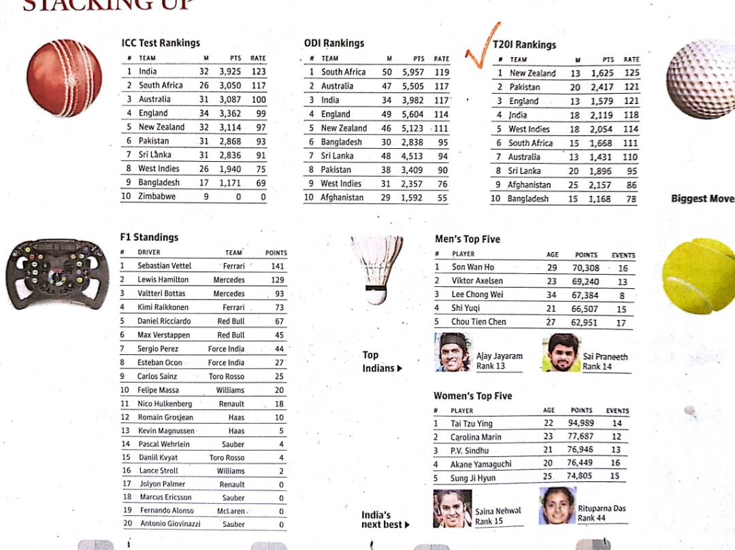

Source (Newspaper): THE HINDU

Dated : 17/06/2017

Page number : 20

**Description-** This data is about different ratings of players and countries based on their respective sport & country. It can be classified as quantitative data because of the points awarded and rating each team and player is given based on their rankings, runs etc. This is also secondary data because the media is borrowing the data from the sports field and giving it to us for reading.

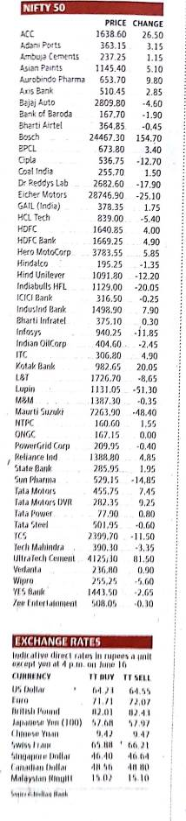

Source (Newspaper): THE HINDU

Dated : 17/06/2017

Page number : 15

**Description-** This data is about different stocks of companies based on their respective progress in the industry & by how much more may their company grow because of the way they have worked in the past. It can be classified as quantitative data because of the progress the company has made and how much have they contributed to the industry. This is also secondary data because the media is borrowing the data from the companies and giving it to us for reading.

3.

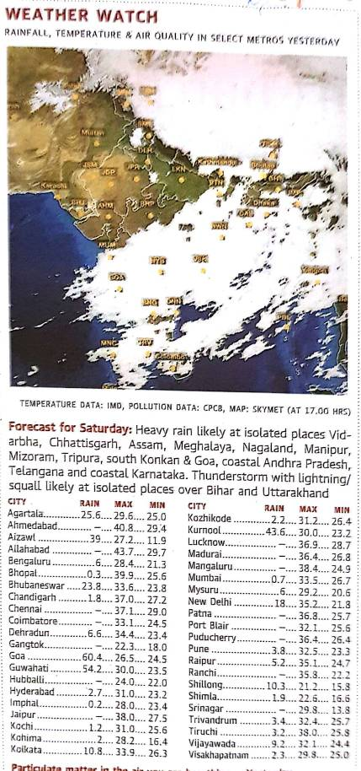

Source (Newspaper): THE HINDU

Dated : 17/06/2017

Page number : 14

**Description-** This data is about different rainfall, temperature & air quality of cities with the actual maximum and minimum rainfall for yesterday. It can be classified as geographical data because of the amount of rainfall which happened. This is also secondary data because the media is borrowing the data from the meteorological department of India and giving it to us for reading.

4.



Source (Newspaper): THE HINDU

Dated : 17/06/2017

Page number : 21

**Description-** This data is about different sport players and their respective market values and performances in the football field. It can be classified as qualitative data because of the attributes of the players and how well they are playing in football. This is also secondary data because the media is borrowing the data from the football industry and giving it to us for reading.